|  |
| --- |
|  |
| CSEA Event Management |
| User Guide (Web) |

|  |
| --- |
|  |

Contents

Introduction 2

Login Page 2

Registration Page 3

Homepage 4

Creating an Event 5

Viewing Your Events 6

Viewing Past Events 8

CSEA Committee Info 9

Viewing Your Profile 9

Logging Out 10

# Introduction

This is a Web-based Application for keeping track of all your upcoming and previously completed events that the CSEA conducts.

# Login Page

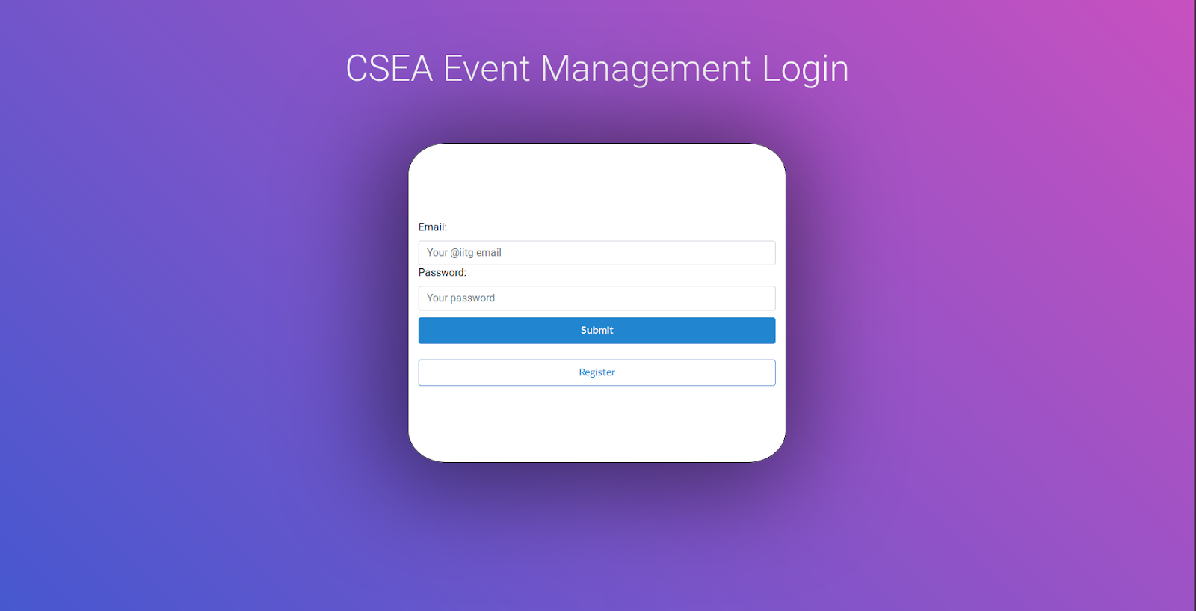

This is your typical login page. Here you enter your Outlook Email address and your Password. Clicking on Submit will take you to your homepage.

However, if your credentials are incorrect, you’ll be prompted to re-enter them.

If you haven’t registered yet, you’ll be able to register by clicking on the Register button, doing which will take you to a registration page.

# Registration Page

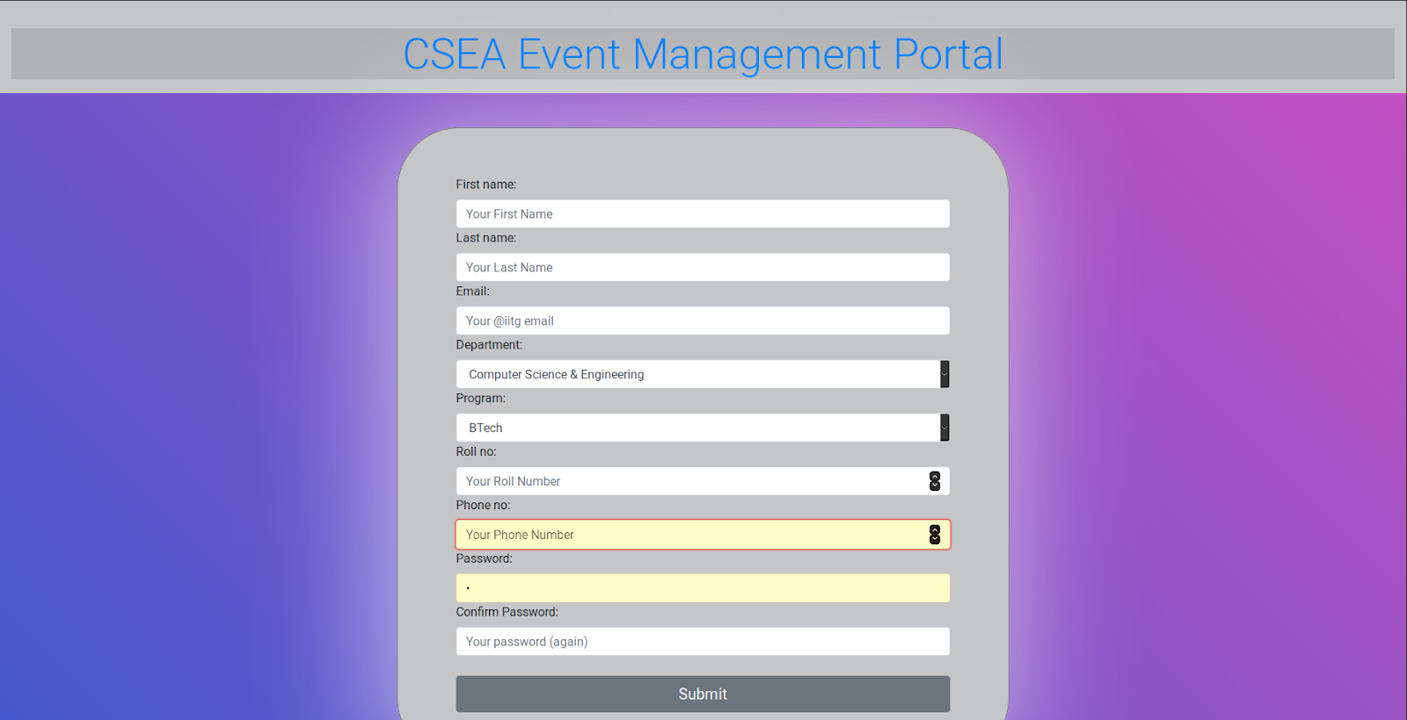

This is the registration page for those who’re not registered users yet. On this page, you enter your details as per the instructions provided in the form. After entering your name, email, course and your contact number, you choose a password.

However, while choosing a password, we strongly suggest you follow these rules:

* Your password shouldn’t be too similar to your other personal information (e.g. your name, your birthday, your license plate number, etc)
* Your password must contain at least 8 characters
* Your passwords shouldn’t be a commonly used password (e.g. qwertyuiop, password, etc)
* Your password can’t be entirely numeric.

# Homepage

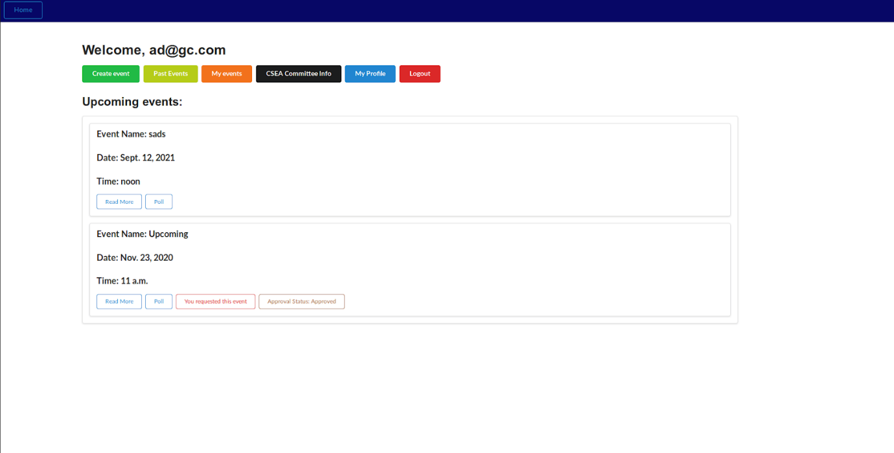

This is your homepage after you have successfully logged in. By default, you will be shown your Upcoming events. You can click on any of the buttons to shown buttons to go to the respective pages. Within an event, you can click on Read More to read more about that event, while you can click on Poll to view the number of people planning to attend that event.

In Read More, you’ll generally be shown information such as the event name, the date and time of the event, the fee you have to pay to take part, contact information of the people in charge of the event, a quick summary and a few FAQs.

At any point, you can click on Home in the top left corner to take you to your home screen.

# Creating an Event

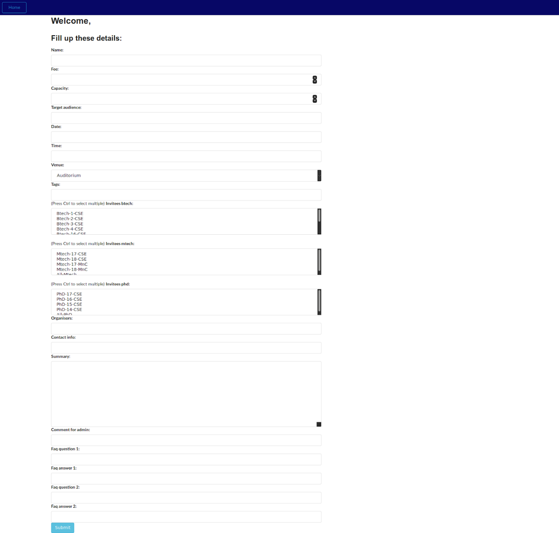

On clicking on Create event button on the homepage, you’ll be greeted with the above screen, which will contain a form where you can enter the information regarding the event you want to create.

You enter the name of your event, the fee required, the capacity (i.e. the maximum number of people that can take part in the event) and the target audience (what kind of people are supposed to take part in the event), the date, time and venue (from a drop-down list) of the event. You can include tags to help people search for the event. It is discouraged to use a lot of tags to increase visibility.

You can invite different batches from each category (i.e. BTech, MTech and PhD) by selecting either one of them, or selecting multiple of them. To select multiple batches, hold down Ctrl while selecting each batch. Of course, you can use All BTech or All MTech or All PhD to invite all batches in that course.

Next you enter the names of the organisers, contact info for inquiries, a quick Summary for the users to know about the event, and a comment for the admin. The event information is sent to the admin for approval, so you have to write this comment appropriately.

Finally, you can add a couple of FAQs for the users to know answers to some questions that may be asked.

If an event is requested by you, you’ll be able to see You requested this event and the Approval Status. Once the admin approves, the status will be set to approved, and other users will be able to view the event. (As seen in the picture below)

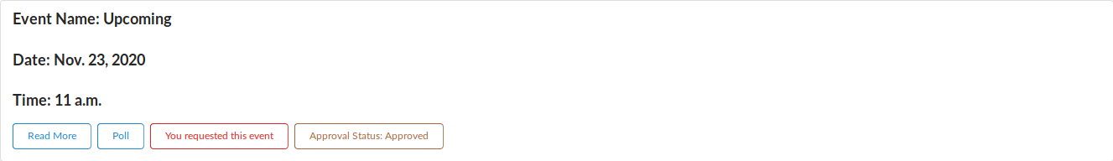

# Viewing Your Events

You can click on the My Events button to show you the events that you have requested.

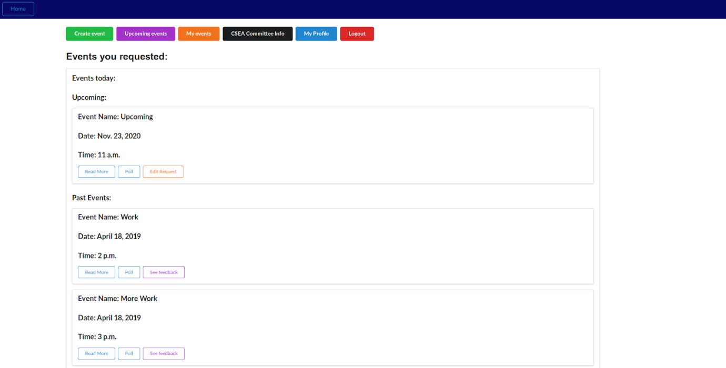

Here, you can see your past events and view their feedback, to help you improve the events for later. Events planned for the current day will appear in Events today

In Upcoming you’ll be able to see the events you’ve requested, and edit your request according to the response you receive. The Edit Request button will take you to the form (as shown below) where you can change as per the requirements.

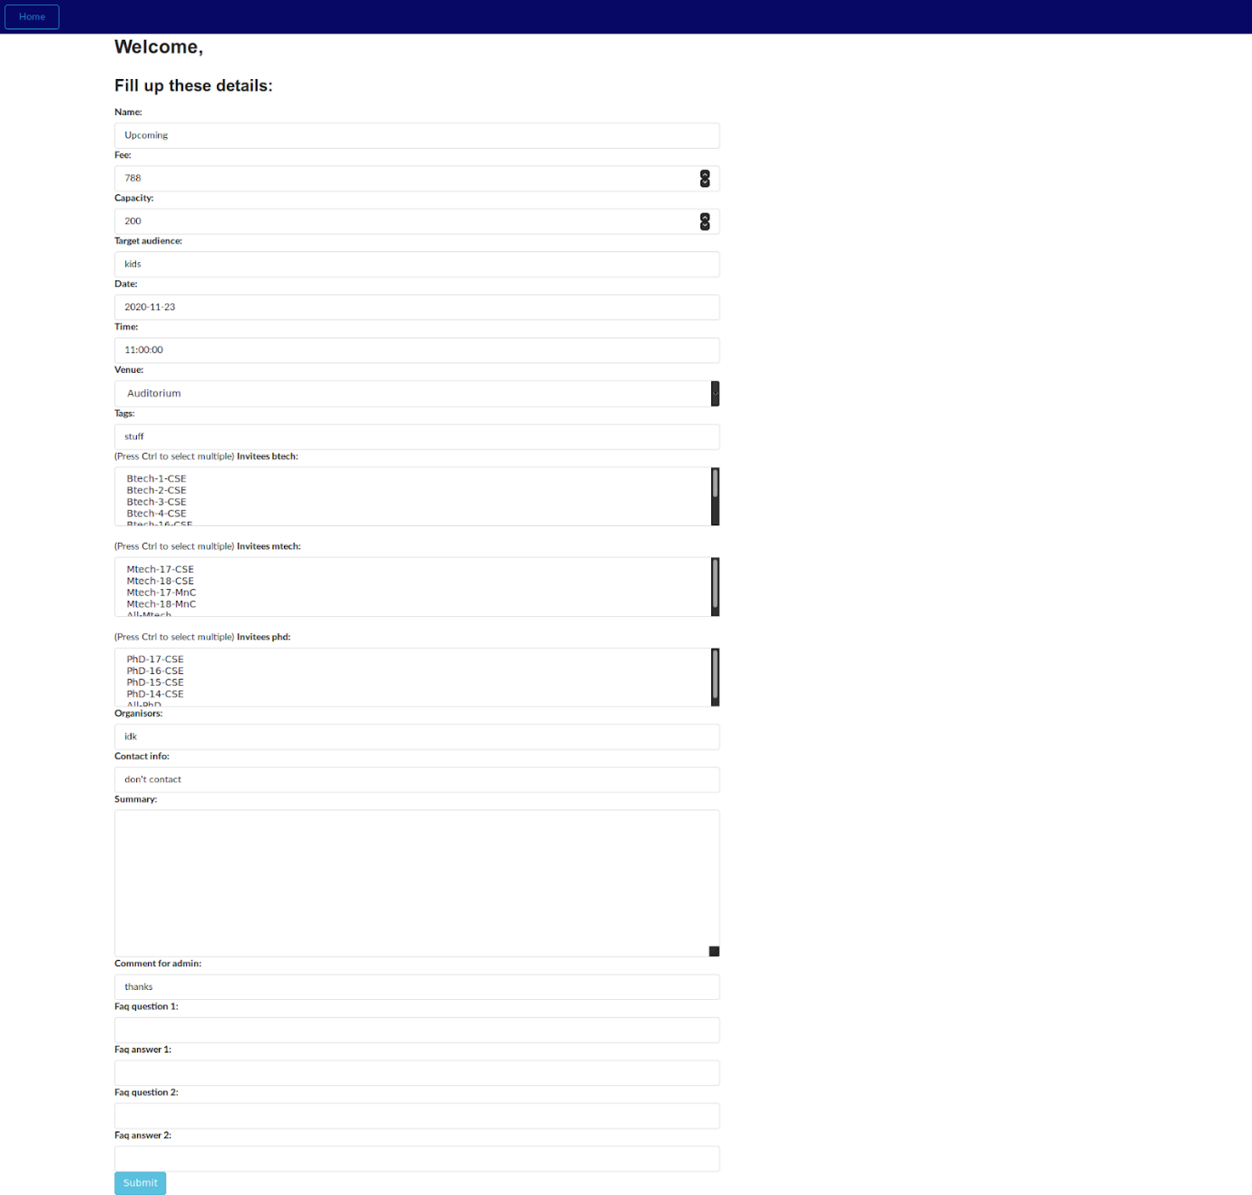

# Viewing Past Events

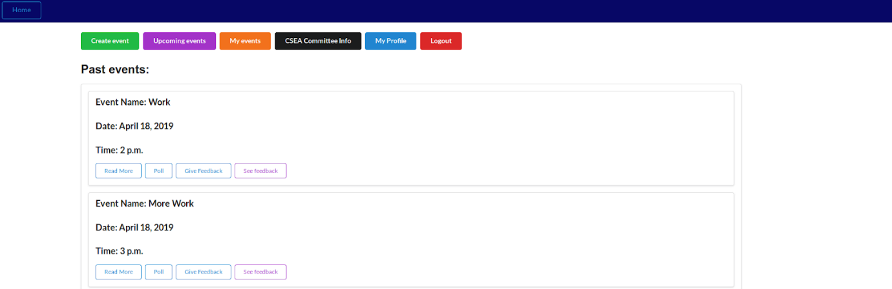

On clicking on Past Events on the homepage, you’ll be shown the events that have been completed. Here, you will be able to give feedback about the event. In the feedback, you can write some text, which can include your experience regarding the event and anything you can that will help the organisers improve the quality of the event. You’ll be also able to give a rating out of 10 for the event.

An example is shown below:

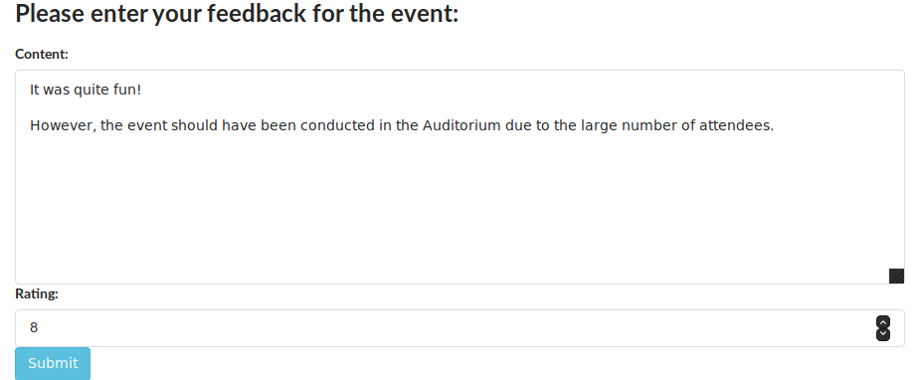

# CSEA Committee Info

Clicking on this button will take you to a page that contains the contact details of the current CSEA Committee. You can contact the committee if you are facing any issues in either creating an event or have any question regarding events, and the organizers are unreachable or unable to resolve your issues.

# Viewing Your Profile

On clicking the My Profile button, you’ll be shown a page containing your profile information.

Here you can change your password. Remember the limitations you have on what you choose your password:

* Your password can’t be too similar to your other personal information
* Your password must contain at least 8 characters
* Your password can’t be a commonly used password
* Your password can’t be entirely numeric

You are reminded of this in the change password page again, and it’s crucial to have a secure password.

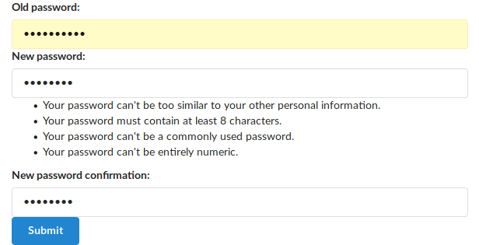

# Logging Out

If for some reason you need to log out, or you’re not on your personal computer, you can log out simply by clicking the red Logout button on the homepage. You’ll be logged out and redirected to the Login Page.